1. Why Transfer Learning? A problem.

Say you have a case where you need a model to classify whether an x-ray or any other medical image shows signs of a disease or condition. Say this condition is rare, or for some reason or another, the amount of labelled image to train a model on is limited such as 2000 images. With only 2000 images, it is impossible to train a deep neural network from scratch and have it be accurate enough to be considered useful. Most probably you would require an amount of labelled images for training in the late hundred thousands or even millions. So what do you do?
The concept of transfer learning
Transfer learning is the practice of having a pretrained model and calibrating it (or fine-tuning it) on the data you have available, to perform a task that ideally (when possible) is similar to what it was originally trained to perform. Instead of training a model from the beginning you begin with parameters set that allow the model to perform certain recognitions, such as edges, textures, shapes and the like. Then you simply modify these already set parameters enough to have the model perform well on what you need.

1.1 An Analogy. Language

Think of a pretrained model and needing to ‘learn’ or ‘get fine-tuned’ like someone learning a new language when they already know one. Say you know how to speak and write Italian fluently. Now say you want to learn Spanish. Chances are you will find it considerably easy. Why? Because both languages use essentially the same alphabet (maybe a few added and removed accents/letters), both languages use the same syntax, both languages share a considerable amount of vocabulary (or slight alterations to the words). They are both languages with Latin roots. There is a considerable amount of overlap between the two, so you do not need to learn things from scratch. In that case ‘fine-tuning’ yourself to learn Spanish when you know Italian will not require too much change, and a good chunk of what you already learned (your internal parameters) you will mostly reuse as is.

If you were to learn english, you will still mostly use the same alphabet and syntax overall. The vocabulary would be considerably different, meaning you would have to ‘forget’ some italian words (this assuming you can only keep 1 language in your head (as models can only classify for 1 task)) and learn the new words for english. This would require a more ‘aggressive’ fine-tuning than Spanish.

If you had to learn Chinese, then most of what you already know regarding the language you’d need to forget. New alphabet, new syntax, new vocabulary. Even how to speak it requires you to do a considerable amount of change. This might require even more ‘aggressive’ fine-tuning, or just might as well forget everything you know and start from scratch, as previous knowledge might prevent you from grasping new knowledge cleanly.

2. How neural network learn

Before moving on to different transfer learning and fine-tuning techniques, it’s best to understand more or less how neural networks work and what pattern emerges in their layers when trained. Transfer learning is possible because the layers in a network end up performing different ‘tasks’, specifically, early layers (closer to the input layer) tend to perform more generic tasks (such as in the case of computer vision, recognizing edges) whilst later layers (closer to the output/classification layer) tend to perform more specific tasks (recognizing a cat from a dog). This behaviour is emergent rather than designed.

2.1 General to specific hierarchy

A deep neural network is composed of multiple layers, where one layer takes the output of the previous layer as input, performs some transformation on that input and forwards its output to the next layer. Even though in most cases the architecture is fairly uniform (different layers are very similar in shape and often perform the same functions) what each layer learns to ‘predict’ is not uniform throughout.

Yosinski et al. demonstrated this in 2014 by literally measuring how transferable the features at each layer were. Zeiler and Fergus (2014) had earlier visualised the same hierarchy directly, using a deconvolution technique to show what kinds of patterns each layer responded to.Both of these findings have been observed across many architectures of neural networks as well as different datasets. As a result, although not always the case, this emergent behaviour has become somewhat a defacto assumption.
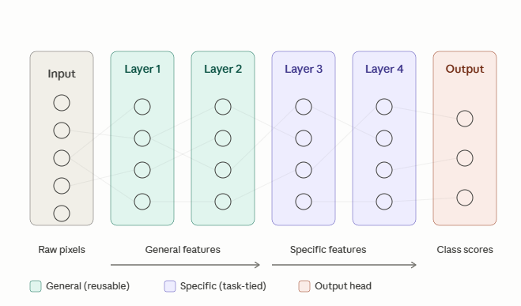

2.2 Vocabulary
- Transfer learning. The general practice of using knowledge gained from one task to improve performance on another. It is an umbrella term that includes everything else in this list.
- Pretraining. The original training of a network on a previous dataset. ImageNet pretraining is the most common example in computer vision.
- Backbone. The pretrained part of the model, minus the final classification layer.
- Head. The final classification layer, typically a single linear layer that maps the backbone's feature vector to your target classes. The head is usually replaced when adapting to a new task because the source classes are different from the target classes.
- Fine-tuning. Continuing to train some or all parameters of a pretrained network on a new target dataset..
- Domain adaptation. A related but distinct subfield concerned specifically with handling differences between source and target distributions, often without labelled target data. Touched on briefly in the section on domain shift.

3. The techniques

There are a total of 4 techniques covered here. Each will be explained and when it might be best to use it and when it is not ideal. Note that in every technique, the Head of the pretrained model has to always be replaced. I highlight it here just to remind you, even though it is obvious.

3.1 Frozen Feature Extraction

This is the simplest form of transfer learning. Here you take a pretrained model and freeze all the parameters in all its layers (so you freeze the backbone), you remove the final classification layer and attach a new randomly initialised (or however it is best to initialise) head. Then you only train the new head. The frozen backbone acts as a feature extractor. In essence the head learns to draw decision boundaries in a vector space that is fixed and unchanging.

For example ResNet50 a CNN trained on ImageNet has a representation space of 2048 dimensions. The new head simply has to learn how to draw boundaries for classification in that space. In simpler terms, you do not change how the network sees the world, you simple change how it labels what it sees.
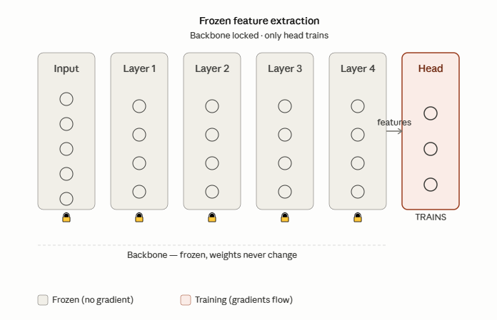

In practice, it is often the case that when fine tuning using this technique, the dataset is ran through once through the backbone, and the output of the last layer before the new Head is stored, and the new Head layer is trained on that output, since the output from the frozen backbone will always be the same.

3.1.1 When to use.
This technique is most applicable when the new dataset you want to fine-tune the neural network on is small AND the domain of the new dataset is similar to the dataset the network was pretrained on. For example, if the pretrained model was trained to classify cats from dogs, and you want to fine tune it to classify Labradors from Pitbulls.

3.1.2 A note.
This technique is often used as the base line when it comes to fine-tuning with other techniques. It is the simplest, fastest, and the least invasive fine-tuning technique as the pretrained network is for the most part (apart from the Head) unchanged. So it is often best to start with this technique before moving on to potentially more invasive fine-tuning.

3.2 End to End Fine Tuning
In end to end fine tuning a new head is initialised as in the previous technique and is attached to the backbone. However, the backbone does not stay frozen. Every weight/parameter inside the backbone is trained alongside the new Head. The training/fine-tuning often uses a much lower learning rate than would be used if the model was trained from scratch. The idea here is that the pretrained weights that are valuable end up not being changed much if at all, whilst the ones that require the most change are gently gradually overwritten.

This is the most aggressive fine-tuning technique, and the one most prone to a condition called ‘Catastrophic Forgetting’. Catastrophic forgetting is the scenario where the backbone’s pretrained weights are changed to the point where there is no benefit taken from having them pretrained, and the pretrained model that has been modified heavily often performs worse than if the model was trained from scratch.

As mentioned, it is often best to use a learning rate that is 10x to 100x smaller than the one used when the pretrained model was trained from scratch. This is small enough that the pretrained weights are nudged towards the newly preferred value rather than overwritten so heavily.

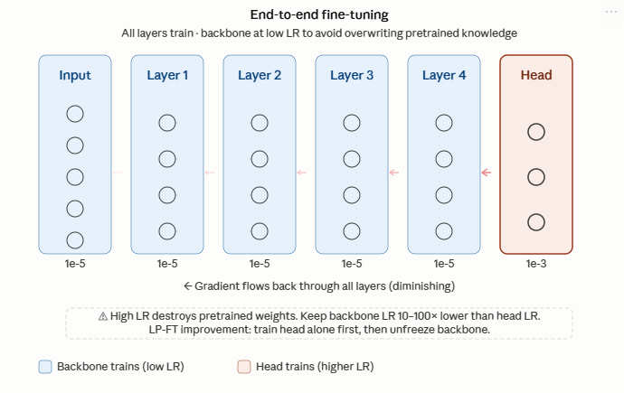
3.3 In Distribution (ID) and Out of Distribution (OOD)
Two important terms worth mentioning now. In Distribution means that the test data comes from the same distribution as the training/fine-tuning data. For example, both test and train/fine-tuning data use the same lighting conditions , same image quality, same object to classify/detect etc. Out of Distribution means the test data comes from (potentially) a related but different distribution. For example different lighting, different image quality, different times of day, but the same object to classify/detect. In most cases, real world deployed models will always be used during inference on OOD data relative to what they were trained/fine-tuned on.

3.3.1 ID/OOD tradeoff
There was a paper that showed that the end to end fine-tuning technique described above produced certain behaviours in models when tested on ID data vs OOD data. Kumar et al showed that compared to Frozen Feature Extraction (first technique explained), models tuned using end to end fine-tuning performed better when tested on ID data, but worse when tested on OOD data. On further observation they noticed that the newly initialised head (often randomly intialised) during fine-tuning was sending chaotic gradients back to earlier already trained layers, causing the pre-trained weights to change drastically, even with the lowered learning rate. Which brings us to their solution.

3.3.2 Linear Probe then Fine Tune
What Kumar et al proposed was simple. First keep the backbone frozen and train the newly initialised head until it is in a sensible space. Then unfreeze the backbone and train everything end to end. This way the somewhat stable head will not send chaotic gradients into earlier layers during Back Propagation.

